2016-2017 Application for Free and Reduced Price School Meals or Free Milk
Complete one application per household. Please use a pen (not a pencil).

☐New Applicant ☐ Previous Applicant

List ALL Household Members who are infants, children, and students up to and including grade 12
(if more spaces are required for additional names, attach another sheet of paper)
STEP 1

Definition of Household Member. “Anyone who is living with you & shares income and expenses, even if not related.”

Children in Foster care and children who meet the definition of Homeless, Migrant, or Runaway are eligible for free meals. Read How to Apply for Free and Reduced Price School Meals for more information.
Child’s Name

Age

Write in name of child’s school, or “not in school”

If a student,
write in the grade
Check all that apply

Homeless, Foster Migrant, Child Runaway

Do any Household Members (including you) currently participate in one or more of the following assistance programs: SNAP, TANF, or FDPIR?
STEP 2

If you answered NO > Complete STEPS 3 and 4. If YES > Write your 9-digit SNAP, TANF, or FDPIR case number here then go to STEP 4
(Do not complete STEP 3)
Case Number:

Write only one case number in this space.

Report Income for ALL Household Members
( Skip this step if you answered ‘Yes’ to STEP 2)
STEP 3

- Child Income
Are you unsure what income to include here?

Flip the page and review the charts titled “Sources of Income” for more information.

The “Sources of Income for Children” chart will help you with the Child Income section.

The “Sources of Income for Adults” chart will help you with the All Adult Household Members section.
Sometimes children in the household earn or receive income. Please include the TOTAL income received by all children listed in STEP 1 here.

- All Adult Household Members (including yourself)

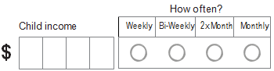

List all Household Members not listed in STEP 1 (including yourself) even if they do not receive income. For each Household Member listed, if they do receive income, report total gross income (b e f o r e t a x es) for each source in whole dollars only. If they do not receive income from any source, write ‘0’. If you enter ‘0’ or leave any fields blank, you are certifying (promising) that there is no income to report.

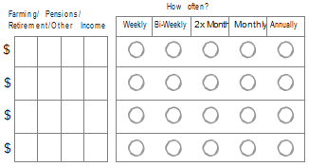
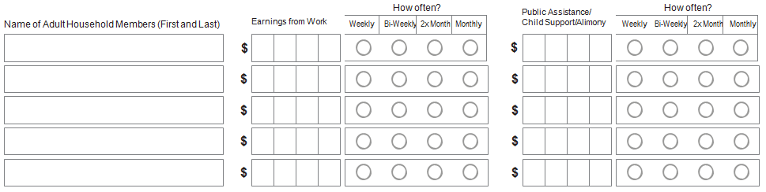

Check if no SSN ☐

Contact information and adult signature. SIGNATURE IS REQUIRED
STEP 4
“I certify (promise) that all information on this application is true and that all income is reported. I understand that this information is given in connection with the receipt of Federal funds, and that school officials may verify (check) the information. I am aware that if I purposely give false information, my children may lose meal benefits, and I may be prosecuted under applicable State and Federal laws.”

Street Address (if available) Apt # City State Zip Daytime Phone and Email (optional)

Printed name of adult completing the form Signature of adult completing the form Today’s date
Sources of Income
INSTRUCTIONS
Sources of Income for Children
Sources of Child Income | Example(s)
- Earnings from work | - A child has a regular full or part-time job where they earn a salary or wages
- Social Security  - Disability Payments  - Survivor’s Beneﬁts | - A child is blind or disabled and receives Social Security beneﬁts  - A Parent is disabled, retired, or deceased, and their child receives Social Security beneﬁts
- Income from person outside the household | - A friend or extended family member regularly gives a child spending money
- Income from any other source | - A child receives regular income from a private pension fund, annuity, or trust

Sources of Income for Adults
Earnings from Work | Public Assistance / Alimony / Child Support | Pensions / Retirement /  All Other Income
- Salary, wages, cash bonuses  - Net income from self- employment (farm or business)  If you are in the U.S. Military:  - Basic pay and cash bonuses (do NOT include combat pay, FSSA or privatized housing allowances)  - Allowances for off-base housing, food and clothing | - Unemployment beneﬁts  - Worker’s compensation  - Supplemental Security Income (SSI)  - Cash assistance from State or local government  - Alimony payments  - Child support payments  - Veteran’s beneﬁts  - Strike beneﬁts | - Social Security (including railroad retirement and black lung beneﬁts)  - Private pensions or disability benefits  - Regular income from trusts or estates  - Annuities  - Investment income  - Earned interest  - Rental income  - Regular cash payments from outside household

Children's Racial and Ethnic Identities
OPTIONAL
We are required to ask for information about your children’s race and ethnicity. This information is important and helps to make sure we are fully serving our community. Responding to this section is optional and does not affect your children’s eligibility for free or reduced price meals.

Ethnicity (check one): ☐ Hispanic or Latino ☐ Not Hispanic or Latino
Race (check one or more): ☐ American Indian or Alaskan Native ☐ Asian ☐ Black or African American ☐ Native Hawaiian or Other Paciﬁc Islander ☐ White

The Richard B. Russell National School Lunch Act requires the information on this application. You do
not have to give the information, but if you do not, we cannot approve your child for free or reduced price
meals. You must include the last four digits of the social security number of the adult household member who
signs the application. The last four digits of the social security number is not required when you apply on
behalf of a foster child or you list a Supplemental Nutrition Assistance Program (SNAP), Temporary
Assistance for Needy Families (TANF) Program or Food Distribution Program on Indian Reservations
(FDPIR) case number or other FDPIR identifier for your child or when you indicate that the adult household
member signing the application does not have a social security number. We will use your information to
determine if your child is eligible for free or reduced price meals, and for administration and enforcement of
the lunch and breakfast programs. We MAY share your eligibility information with education, health, and
nutrition programs to help them evaluate, fund, or determine benefits for their programs, auditors for
program reviews, and law enforcement officials to help them look into violations of program rules.

In accordance with Federal civil rights law and U.S. Department of Agriculture (USDA) civil rights regulations
and policies, the USDA, its Agencies, offices, and employees, and institutions participating in or
administering USDA programs are prohibited from discriminating based on race, color, national origin, sex,
disability, age, or reprisal or retaliation for prior civil rights activity in any program or activity conducted or
funded by USDA.
Persons with disabilities who require alternative means of communication for program information (e.g. Braille,
large print, audiotape, American Sign Language, etc.), should contact the Agency (State or local) where they
applied for benefits. Individuals who are deaf, hard of hearing or have speech disabilities may contact USDA
through the Federal Relay Service at (800) 877-8339. Additionally, program information may be made
available in languages other than English.

To file a program complaint of discrimination, complete the USDA Program Discrimination Complaint Form,
(AD-3027) found online at: http://www.ascr.usda.gov/complaint_filing_cust.html, and at any USDA office, or
write a letter addressed to USDA and provide in the letter all of the information requested in the form. To
request a copy of the complaint form, call (866) 632-9992. Submit your completed form or letter to USDA by:

mail: U.S. Department of Agriculture
Office of the Assistant Secretary for Civil
Rights 1400 Independence Avenue, SW
Washington, D.C. 20250-9410
fax: (202) 690-7442; or
email: program.intake@usda.gov.
This institution is an equal opportunity provider.

FOR SCHOOL / CENTER USE ONLY
Do Not Fill Out
Do not convert single income frequency. Annual Income Conversion: Weekly x 52, Every 2 Weeks x 26, Twice a Month x 24, Monthly x 12.

Total income: How Often? Household Size: Categorical Free Eligibility: (Select 1) Income Eligibility: (Select 1)
Weekly | Bi-Weekly | 2xMonth | Monthly
Foster | Homeless | Runaway | Migrant | SNAP/TANF  /FDPIR
Free | Reduced | Denied

Determining Official’s Signature Date Confirming Official’s Signature Date Verifying Official’s Signature Date

