TABLE OF CONTENTS

Mission Statement / Vision / Beliefs | Page 2
Narrative District Profile | Pages 3-4
Statistical District Profile | Pages 5-7
Achievement/Accountability Data
- College and Career Readiness/ACT Scores | Page 8
- Elementary Reading Proficient & Advanced | Page 9
- Elementary Math & Middle School Reading | Page 10
- Middle School Math & High School Reading  - High School Math & District Science | Page 11  Page 12
District Goals/Strategies/Indicators | Pages 13-18
Needs Assessment | Pages 19-21
Staff Development Plan | Page 23
Intervention Strategies | Page 23

1

White Lake School District #1-3

Mission Statement:
Showing White Lake PRIDE – It is our mission to develop Productive, Responsible, Independent learners, Dedicated to Excellence.

Vision:
“It is the vision of the White Lake School District #1-3, through a partnership and shared responsibility of a school community composed of administrators, teachers, students, parents and community members, to provide a school where students are given the opportunity to thrive academically, socially, emotionally, and physically. As a school community, we envision an environment of intellectual stimulation to achieve optimal student performance and to instill a true love for learning in our students. Our staff will foster classroom environments in which diverse scientifically-based learning strategies are implemented in order to meet the content standards. Staff will stay abreast of these strategies through continuous professional development. We see computers and technology as tools to develop higher level thinking skills, enhance creativity, and encourage personal expression, hence creating a population of life-long learners. We see the school community as being exposed to updated technology through curriculum integration, staff development, and various educational opportunities.”

Our beliefs:
- Learning is a life-long process with critical thinking, decision making, and problem solving as key components.

- Each student is a valued individual with unique physical, social, emotional, and intellectual needs.

- Curriculum and instructional practices should incorporate a variety of learning activities to accommodate differences in learning styles.

- Students, teachers, administrators and parents have a shared responsibility to advance the mission, philosophy and beliefs of the school.

- Parental involvement and community support are essential ingredients for collaboration with teachers, staff, and administrators if students are to become confident, self-directed, life-long learners.

2

2012-2013 Narrative Profile

Section 1: Unique Local Insights-District Information
White Lake is a small, vibrant community of approximately 405 people located along Interstate 90 in south-central South Dakota. The White Lake School District is comprised of 241 square miles of both Aurora and Brule counties, with the actual school building lying in Aurora County. The elementary, junior high, high school, and administration offices are conveniently housed under one roof. We provide bussing service to our rural families, but many of our secondary students choose to drive to school as a result of their heavy involvement in after-school activities.

White Lake lies approximately 35 miles west of Mitchell and 35 miles east of Chamberlain. Both of these cities, along with our local businesses provide ample shopping and recreational opportunities. With the Missouri River less than a half hour away, White Lake is perfect for lovers of camping, water recreation and fishing. A wealth of wildlife provides ample opportunity for the hunting enthusiast as well. In fact, White Lake has become an autumn destination for hunters from all over the United States to stay in our numerous hunting lodges and take advantage of the abundance of hunting opportunities we offer.

Academic achievement runs high in the White Lake School District as highlighted in our accomplishments:
2005 | Title 1 Distinguished School (K-6)
2006 | Writing to Win Exemplary School (K-12)  Blue Ribbon School (K-12)
2007 | Writing to Win Exemplary School (K-12)
2009 | Named one of the Best High Schools by U.S. News & World Report
2011 | Ranked #1 among all SD High Schools in Average Math ACT Scores
2012 | Recognized as Exemplary Elementary School (K-6)  Ranked #1 among all SD High Schools in Average Math ACT Scores
2013 | Recognized as Exemplary Elementary School (K-6)  Named one of the Best High Schools by U.S. News & World Report

Technology is a focus with the White Lake district as well. We provide two computer labs as well as placing computers in every classroom. All 9-12 students are provided with their own laptops and many of their classes are enhanced by the use of those computers. Our junior high and elementary
3

students also have access to 2 wireless labs comprised of approximately 30 laptop computers. We also have one desktop lab which is used daily for elementary computer classes.

We provide two distance-learning classrooms where our students and community members can take advantage of classes offered through the Dakota Digital Network. Most frequently, we use the DDN to enhance our curriculum by offering classes such as Senior Math, Art, and Spanish I. All students in 11th grade are also enrolled in an on-line Health course.

Each member of the teaching staff has been provided with a computer notebook for educational use. A large number of our teachers have participated in Technology for Teaching and Learning (TTL), advanced TTL, and Distance Teaching and Learning (DTL) academies to stay abreast of current technology and techniques for integrating technology into the classroom. To aid in technological integration, we have five portable projectors available for classroom use, and four classrooms are equipped with ceiling mounted projectors. All elementary classrooms have been equipped with SMART-boards which are used daily.

Not only does the White Lake school district succeed academically, but they excel in extra-curricular activities as well. On the athletic side, they offer volleyball, football, girls and boys basketball, wrestling, track, and golf. All sports, with the exception of golf, are part of a coop with our neighboring district, Kimball. Our athletic teams have been presented with Academic Team Awards from the South Dakota High School Activities Association for a number of years.

Having a strong music program is a high priority for the White Lake community. Consequently, 1 class period per day is set aside for chorus and band. Virtually every student is involved in one or both programs. A strong music program sends students to participate in various band and vocal festivals and contests every year, not to mention All-State Band & Chorus and Honors Choir.

A number of the students, grades 9-12, are also involved in our recently added Oral Interp. program. Individuals in this program have had success at the district level already.

The White Lake School District utilizes an after-school program with a focus on extending learning opportunities for all students in grades K-6. A snack is

provided for those students who attend. Teachers and community volunteers are on hand to directly assist students with homework and to lead learning activities.

4

Section 2: Student Characteristics
The current enrollment of the White Lake School is 114 students, with Three attending through open enrollment. Projected enrollments indicate that the White Lake school is losing student enrollment, but will consistently be at the 110-120 enrollment number. Many students (37.3%) in the district come from economically disadvantaged families. The district is a Title I school with grades K-6 being served as part of a School-wide Title I program. Six percent of the school’s population receives Special Education services. The table below indicates a breakdown of the district’s demographics.
Student Group | % of Total Students
White | 88.9%
Native American | 0.8%
Black | 1.6%
Hispanic | 8.7%

As a smaller school, the discipline problems in the district are minimal. Each family is provided with a student handbook, which outlines all the policies and procedures of the district. Each family and their student(s) is responsible for reviewing the handbook and signing and returning a contract stating that they have read, understand, and will abide by the said policies.

The graduation rate of the White Lake School is 100%. Those students who begin twelfth grade in our system and also completed the twelfth grade determine the graduation rate.

The attendance rate of the district as a whole is 95.79%. The district has consistently exceeded the attendance goal, but would like to improve the attendance rate at the high school level.

Section 3: Instructional Data
The White Lake School District consists of 12.27 Certified Teachers. all of whom are considered Highly Qualified by the SD Dept. of Education or on a plan of intent to become Highly Qualified. The District also employs six para-professionals, all Highly Qualified as well. Administratively, the district employs one superintendent, who also serves as K-12 principal. We also have two lead teachers, one in each the Elementary and the Jr. High/High School, to share some of the administrative duties. The district has a full time Technology Coordinator full time. The gender makeup of the staff is 20 females and 7 males. The staff ethnicity is 100% Caucasian. The district’s students benefit from a student to teacher ratio of 9.5:1. The district contracts with Mid-Central
Educational Coop to provide physical, occupational, and speech therapy services, as well as a school psychologist on an as-needed basis.

5

Personnel Data
Certified Teachers | 12.4
Administration | 1
Paraprofessionals | 7
Maintenance | 2
Office Personnel | 1
Student to Teacher ratio | 9.5:1
% Highly Qualified Teachers | 100%
% Teachers with Bachelor’s Degree | 100%
% Teachers with Master’s Degree | 50%
Teacher Retention Rate | 89%
Staff Living in School District | 61%
Staff Ethnicity | 100% Caucasian

Section 4: Financial Data
Financial data from the 2007-08 school year for the White Lake School District is compiled in the table below.
Financial Data 2012-2013
Local Contribution | $592,765
County Contribution | $36,548
State Contribution | $527,410
Federal (Title Funds) | $69,308
Federal (Impact Aid) | 0
Tax Levy  - o Agriculture  - o Non-Ag Z  - o Owner Occupied  - o Other Non-Ag/Utilities  - o Special Education  - o Capital Outlay  - o Bond Redemption  - o Pension Fund | $2.322  $3.8  $4.26  $6.309  $13.512  $1.00  $.750  $0  $.30
Per Pupil Spending | $8,838
Teacher Base Salary | $29,925
Average Teacher Salary | $36,209
Substitute Teacher Pay  - • Certified  - • Non-certified | $80/day  $60/day
6

Section 5: Community Data
The White Lake School District is located in agriculture country. As a result, a majority of the students originate from families who either farm or ranch their own land. or from families who lease farm land. Other employment opportunities for the White Lake area residents include the skilled and unskilled positions at the Aurora-Brule Nursing Home, the manual labor positions at the Cenex fertilizer, fuel, propane, and retail plant, and the many labor positions provided in the surrounding communities of Mitchell, Chamberlain, and Platte. The White Lake School is the second largest employer within the school district with 33 employees – 6 of whom are White Lake graduates. The economic conditions of the district are such that several parents hold down more than one job to make financial ends meet.
Approximately 53% of the families are eligible for free and reduced meals through the USDA School Lunch Program. This program allows children whose families are unable to pay the full price for meals to receive them free or at a reduced cost. Observed employment choices and income levels would indicate that few parents have a college education.
The school is the focal point of the community. Invitations to get involved with the school are continually extended to all community members. We have hosted community involvement programs on an annual basis, such as Book Buddies, Family Math Night, Read Across America Day, and Grandparents Day. As a result of this positive relationship, many parents, grandparents and young adults are comfortable using school facilities for their own personal benefit – computer labs, DDN Distance Learning Labs, weight room, and the gymnasium. Several parents and grandparents are willing volunteers during after-work hours, but because of their own employment, it is extremely difficult for them to assist during school hours.

The taxpayers within the district are supportive of the school. In 2012 they supported a $200,000 tax increase (opt out) to maintain their school. They demand excellence from school officials, but are very supportive of the school’s efforts.

7

Achievement/Accountability Data
White Lake School District

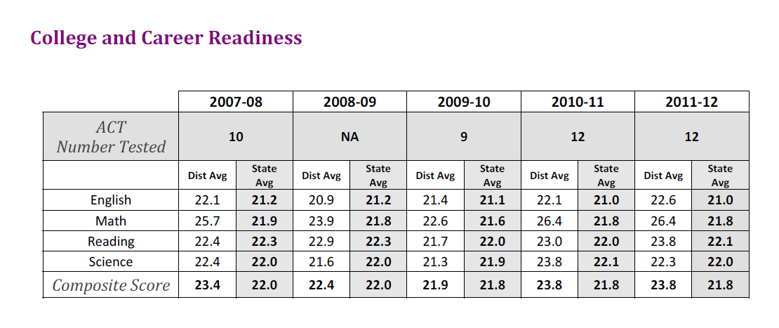

8

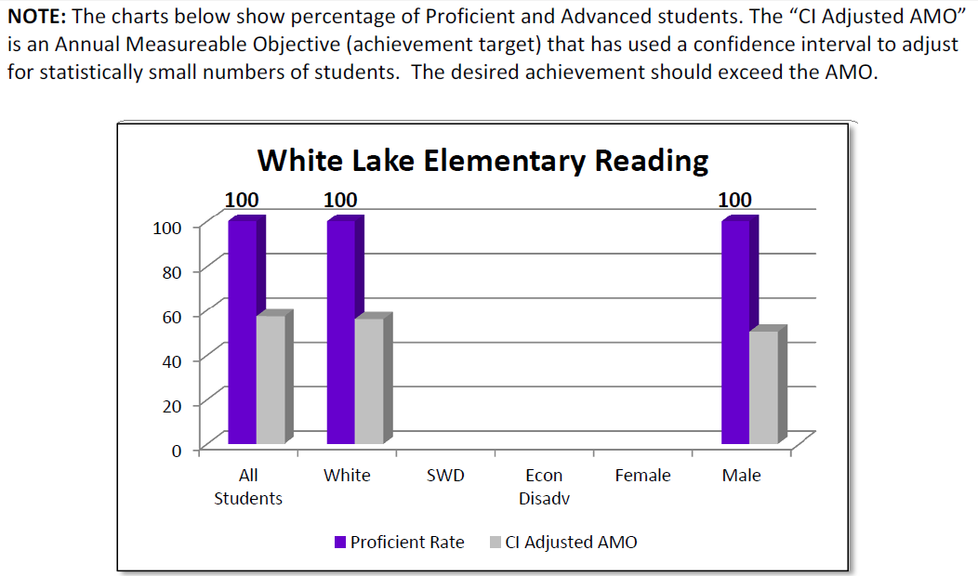

9

10
White Lake School District 1-3

11

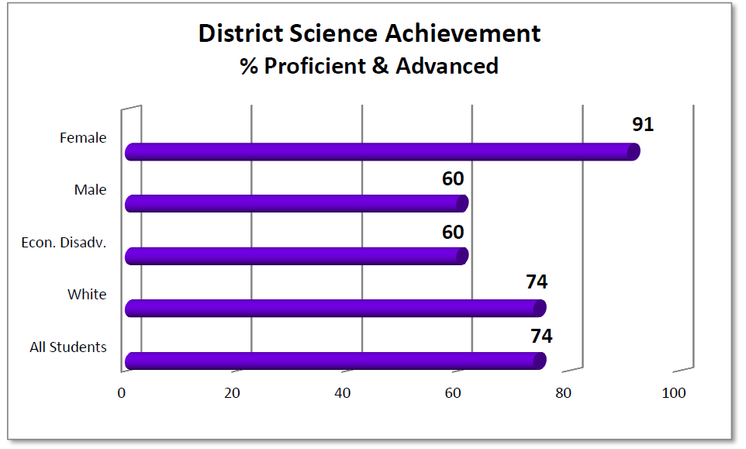12

Goals for White Lake School

District Goals: Reading Goal: Our students will be at or above the State Average
Measurable Objective(s) To Meet Goal | Programs, Strategies, Activities To Achieve Objective(s) | Performance Indicators | Funding Source That Will Support Objective(s)
80% of Kindergarten students will be proficient in letter recognition and sounds as indicated on district assessments in 2014  80% of the students in grades 1-2 will read at an independent lever at the end of the school year as indicated on district assessments in 2014.  80% of students in Grades 3-5 will read at an advanced or proficient level at the end of the year as measured by State assessment in 2014.  80% of the students in grades 6-8 will be proficient or advanced in reading at the end of the year as measured by State Assessment in 2014.  75% of the students in 9-12 will be proficient or advanced in reading at the end of the year. as indicated on the State Assessment in Grade 11 in 2014.  50 % of students in the sub-group of Special Education, 3-8, & 11 will be proficient in reading at the end of the year, as measured by the State Assessment in 2014. | - Grades K-6  - Guided Reading strategies  - Paraprofessional support in classroom  - Guided Reading Strategies  - Content Standard Alignment plan  - 21st Century After-School Program  - Business Book Buddies  - Professional Development for all teachers  - Tutorial Software  - Web Site Coordinator  - Tech Coordinator  - Smart Board  - Benchmark Assessment  - Open house K-6  - Newsletter  - Online Grading  - Computer policy night 9-12  13 | - Fall/Spring Classroom Assessments  - DIBELS 3X a yr  - Smarter Balanced State Assessment, SAT 10  - DRA's 2 X a yr  - DIBELS 3 X a yr  - Achievement Series | Title I  Part A  REAP  Special Education

District Goals:

Math Goal: Our students will be at or above the State Average
Measurable Objective(s) To Meet Goal | Programs, Strategies, Activities To Achieve Objective(s) | Performance Indicators | Funding Source That Will Support Objective(s)
80% of the students in kindergarten will score in the average range at the end of the 2014 school year.  80 % of the students in Grades 1-2 will score in the average range at the end of the 2014 school year.  80% of students in 3-5 will be proficient or advanced in math at the end of the year as measured by the State Assessment in 2014.  80% of the students in grades 6-8 will be proficient or advanced in math at the end of the year as measured by State Assessment in 2014.  75% of the students will be proficient or advanced in math at the end of the year, as indicated on the State Assessment in Grade 11 in 2014. | - Classroom assessments 2X a year  14  - Classroom Assessments 2X a year  - Paraprofessionals  Provide Additional assistance in Math instruction for those student with special needs.  - Daily Oral Math/Math Meeting  - Math Family Fun  - Content Standard Alignment Plan  - 21st Century After school program  - Professional Development for all teachers  - Counseling in Grades K-6 classrooms  - Tutorial Software  - Parent Involvement.  - Parent/Teacher Conferences  - On Line Grading  - Computers for each student in grades 9-12 | - Smarter Balanced Assessment  - Achievement Series  - Smarter Balanced Assessment | Title I Part A  REAP  Special Education

15
Goals for White Lake School

District Goal: To improve student Technology skills
Measurable Objective(s) To Meet Goal | Programs, Strategies, Activities To Achieve Objective(s) | Performance Indicators | Funding Source That Will Support Objective(s)
80% of the students in Grades K-2 will be able to locate a given key upon request in grades K-2.  All elementary students will be proficient in keyboarding skills in grades 3-8. | - Smart Boards in classrooms.  - Computer class 1X a week | - Classroom assessments  - Classroom Grades | - General Fund

District Goal: All students will graduated from High School
Measurable Objective(s) To Meet Goal | Programs, Strategies, Activities To Achieve Objective(s) | Performance Indicators | Funding Source That Will Support Objective(s)
100% of the students will graduate from High School. | - Regular attendance will be encouraged by staff. | - State Report card will show results | - General Fund

16
Goals for White Lake High School

District Goal: The White Lake School District will by a drug free and safe campus.
Measurable Objective(s) To Meet Goal | Programs, Strategies, Activities To Achieve Objective(s) | Performance Indicators | Funding Source That Will Support Objective(s)
100% of the students in grades K-12 will show good character and follow our no tolerance for Bullying pledge in the school.  100% of the students in grade 5 will complete the D.A.R.E. program provided by the Aurora County Sheriff’s Office. | - Counseling will be provided if the need arises.  - Completion of the D.A.R.E. program | - Surveys completed by the counselor. | General Fund

District Goal: The White Lake school will provide each student the opportunity to become proficient or advanced in the skills of Science.
Measurable Objective(s) To Meet Goal | Programs, Strategies, Activities To Achieve Objective(s) | Performance Indicators | Funding Source That Will Support Objective(s)
All students in grades K-8 will participate in Common Core standards based Science Curriculum.  All teachers will receive professional development pertaining to effective instructional strategies, aligned assessment, and Common Core Standards. | - Classroom assessments.  - On Line Grading  - Standards noted on the curriculum map and on lesson plans  ESA staff/in-service training | - Smarter Balanced State Assessment  17 | - General Fund  General &  Title I funds
Goals for White Lake Special Education Students

District Goal:
The White Lake School will provide students with the Least Restrictive Environment.
Measurable Objective(s) To Meet Goal | Programs, Strategies, Activities To Achieve Objective(s) | Performance Indicators | Funding Source That Will Support Objective(s)
All students in the White Lake school district will have the opportunity to participate the in Regular classroom when appropriate. | - Paraprofessionals  - Accommodations | - Students will meet proficiency standards according to Smarter Balanced assessment. | SPED

Needs Assessment
18

Perception Data
Staff Perceptions of Strengths and Weaknesses …
Of the Students
A majority of the teaching staff (54%) believes that parental involvement is lacking. While, 40% of the staff believes that students do not have a positive attitude toward learning. Even though White Lake is a small school, 85% of the staff believes that the curriculum is extensive enough that graduates are not hampered in their vocational choice.

Of the Curriculum
Eighty-five percent (85%) of the staff believes that the class offerings are adequate for the students to succeed in the vocation of their choice. Seventy (70%) believe that integration of technology into the classroom is adequate. More staff (85%) believes that math skills are being stressed throughout the curriculum than reading skills (70%).

Of the School Atmosphere
One hundred percent (100%) of the staff believes that the school is well kept and clean. Eighty-five percent (85%) of the staff believes that the discipline within the school is good, but (23%) of the staff believes that there is bullying taking place within the school.

Of the Staff
Eighty-five percent (85%) of the staff believes that they and their fellow teachers are well prepared to teach the students at White Lake, and (85%) of the teachers believe that the teachers are willing to help the students.

Student Perceptions of the White Lake School System…
- 90% of all 9-12 grade students believe that White Lake provides a quality educational opportunity for them
- 90% of the students believe that the technology education that they receive is very good
- 85% of the students believe teachers are caring and helpful
- 80% believe that the students are well-behaved in the classroom
- 90% do not have any problems with other students
- 80% believe the rules in the handbook are OK and enforced correctly
- 96% get along with their classmates
- 92% believe that the school library is adequate for their needs
- 56% believe that there is favoritism within the system
*There were a possible 832 student responses, and 77% of the responses were marked as positive, agree or strongly agree.

19
Academic Teaching Staff Survey of Technology Needs…
One hundred percent (100%) of the staff believes that the White Lake students will need the same technical skills and knowledge as other South Dakota graduates. However, only 75% believe that the White Lake Faculty needs to provide any additional technology opportunities. Plus, only 75% of the academic staff is willing to learn how to better integrate technology into their classroom, or can think opportunities to do so.

Ninety-two percent (92%) of the White Lake Staff believes that the White Lake graduates entering college and vocational school will need more exposure to technology than they are currently receiving, but only 67% believe that laptop computers will increase knowledge.

Eighty-four percent (84%) of the White Lake staff believes that local professional development is best when provided by other White Lake staff members.

The White Lake Graduate Follow-up Survey indicated that…
- 90% of the graduates believe the White Lake School prepared them for college and/or their current career
- 100% of the graduates believe that they were treated with respect while they were in school
- 90% of the graduates believe that they had the same opportunities to succeed while they were in attendance
- 100% of the graduates said they had a positive experience while attending the White Lake School District
- One recurring comment was the desire for more and varied class offerings

Comprehensive Needs Assessment
The process for determining the needs of our district was three-fold, conducted by the Title I Consolidated Application Committee. The first step was the completion of a comprehensive needs assessment by parents. The second step was to evaluate data from performance indicators, such as DakotaSTEP and DACS test scores, and DIBELS and DRA results. This information was compiled on Tuesday, April 29, 2008. In examining "protective" and "risk" factors, we reviewed attendance and drop-out rates, suspension and expulsion rates, participation numbers in after-school and extracurricular activitites, family demographics and make-up, pregnancy rates, and alcohol and drug abuse data.

Data from our Comprehensive Needs Assessment includes:
Strengths
- a majority of the teachers believe that the class offerings are adequate for the students to succeed in the vocation of their choice
- the integrating of technology into the classroom is adequate
- math skills are strong across the grades
- the atmosphere of the school is clean and well kept
20
Weaknesses
- staff members feel that reading skills continue to be a struggle
- reading in the content area seems need more emphasis
*This will continue to be a conscious point of improvement throughout the next school year, providing staff with continued support and professional development. Reading skills and strategies taught across the curriculum will create more success for all students.
- Parental involvement in academics is lacking

Data Retreat/Data Analysis
The School Leadership Team, consisting of Mrs. Moeller, Miss VanSoest, Ms. Moore and Mr. Hoffman, attended a one-day data retreat onSeptember 19, 2013 using Common Core and Smarter Balance information. Through the process, we examined the data from four perspectives: student data, programs and structures data, professional practices data, and family and community data. The team analyzed data, and worked to formulate improvement plans that would result in improved student achievement and informed instruction for our staff.

The Leadership Team will take this information back to the school and inform the teachers of methods to achieve the goals we have set as a district. The outcome of this workshop was the identification of patterns, standards of concern, and the focus on individual needs as a whole district, then each staff member identified specific needs in their content area and created a plan to remediate the area/standard of concern.

Staff Development Plan
21

The White Lake School is committed to providing a quality education for the students in attendance. Believing that increasing the quality of instruction is the number #1 way to increase student learning, the following professional development plan was created for the 2013-2014 school year.

*ESA 3 will provide grade level coaching for elementary teaching staff. This coaching will take place during 4 afternoon sessions throughout year. Additional follow-up may occur at the request of the teachers.

*ESA 3 will provide session on SD-STARS for all teaching staff. Friday, January 17, 2014. (½ day)

*EAS 3 will provide session on Implementing Common Core Standards and Using the Smarter Balanced Assessment. Tuesday, February 11, 2014. (½ day)

*ESA 3 will provide training on Aligning Curriculum to the Common Core Standards. Wednesday, May 7, 2014. (full day)
22

***Waiting on confirmation from ESA 3 on dates and times
Intervention Strategies

White Lake strives to design our instructional strategies with the purpose of school improvement in mind. Our district is small enough that the teachers are able to pinpoint ‘bubble children’ and target them for intervention. As a district, we make it a priority to plan and set in motion instructional strategies with this purpose in mind.
Our staff spends time each fall pouring over Data Analysis information. Not only do we address school-wide issues, such as reading in the content area, but we also spend time targeting specific classroom standards noted individually as weaknesses. Teachers identify precise standards that students consistently struggle within their individual subject areas. The highly qualified instructors then outline strategies that will be put in motion to raise the performance on these targeted standards. This practice provides measurable goals for each instructor to work towards.
Some of the intervention strategies utilized within the White Lake School District are outlined below.

Intervention Strategies

- Data driven instruction derived from using the information obtained from analyzing Dakota STEP Test results.
- Using teacher aides in all K-6 classrooms for tutorial assistance.
- Utilizing the search engine “Netrekker” for classroom research.
- Utilizing lap top computers at all levels of instruction K-12.
- Scheduling 1 hour of the after school program to focus on math and reading skills.
- Utilizing after school or “extended school time” for tutorial instruction for students who can’t or won’t complete daily assignments.
- Utilizing a “Boost Up” physical education program to increase physical coordination and learning.
- Using the data from DIBELS Testing to develop reading lessons.
- Integrating “Math Counts” into regular math series to insure higher math comprehension.
- Utilizing the strategies form “Guided Reading” to enhance K-6 reading and language arts programs.
- Utilizing the “Achievement Series” Program to test the level of understanding of certain content standards.
23

